**DJANGO**

**1. Install of Python**

https://www.python.org/downloads/

**2. Installation of PyCharm**

https://www.jetbrains.com/pycharm/download/#section=windows

# IDE: PyCharm

# Help (Menu) -> **About**

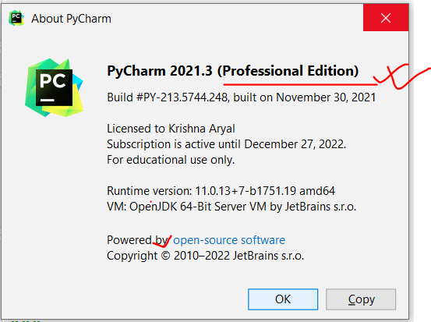

**3. Creating new Project (Django Project -> Website)**

* **File** (Menu) > **New Project**

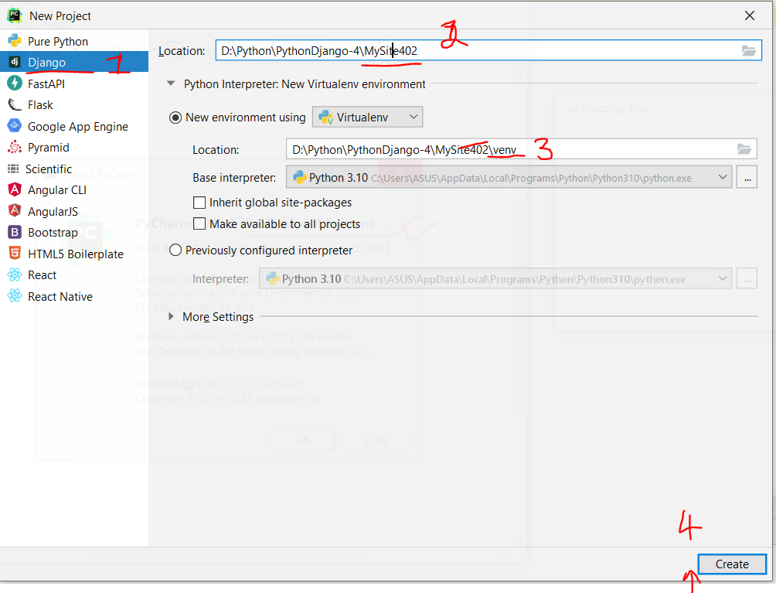

* Click on **Create** button

**4. Explore Django Project**

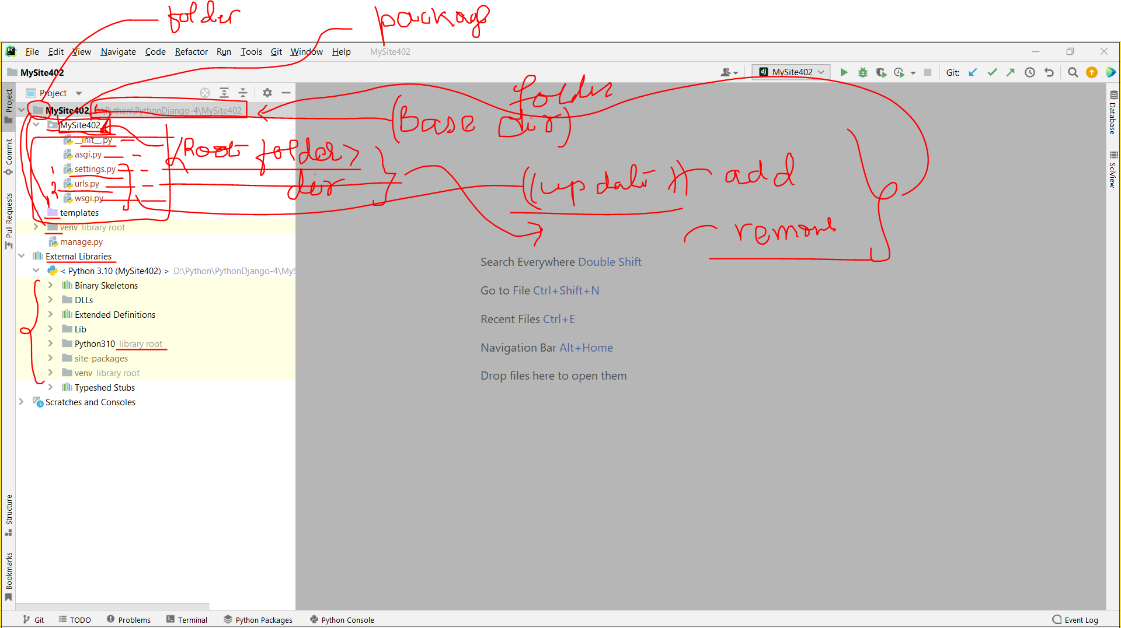

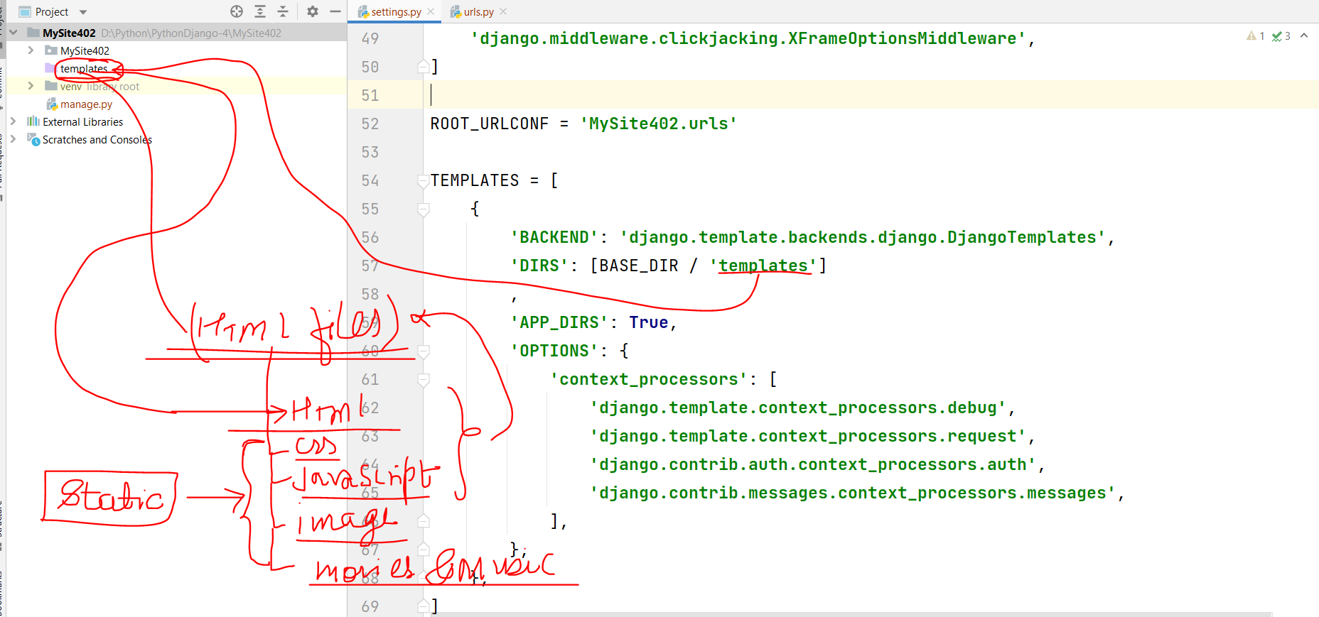

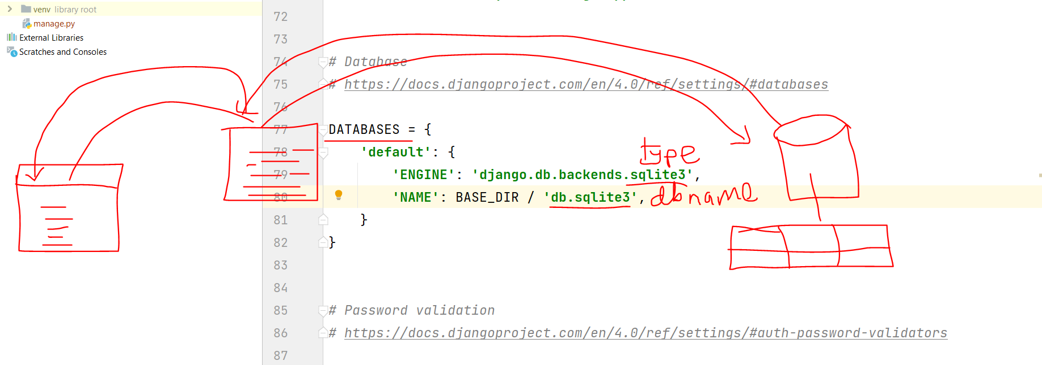

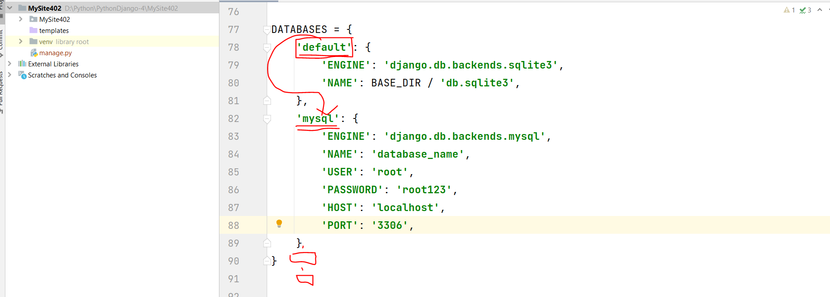

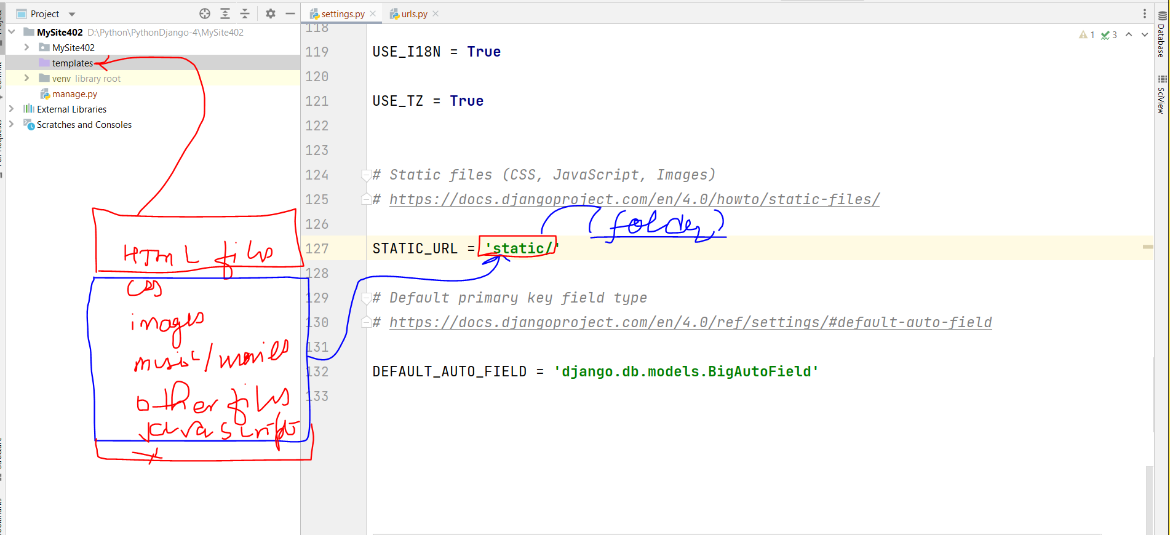

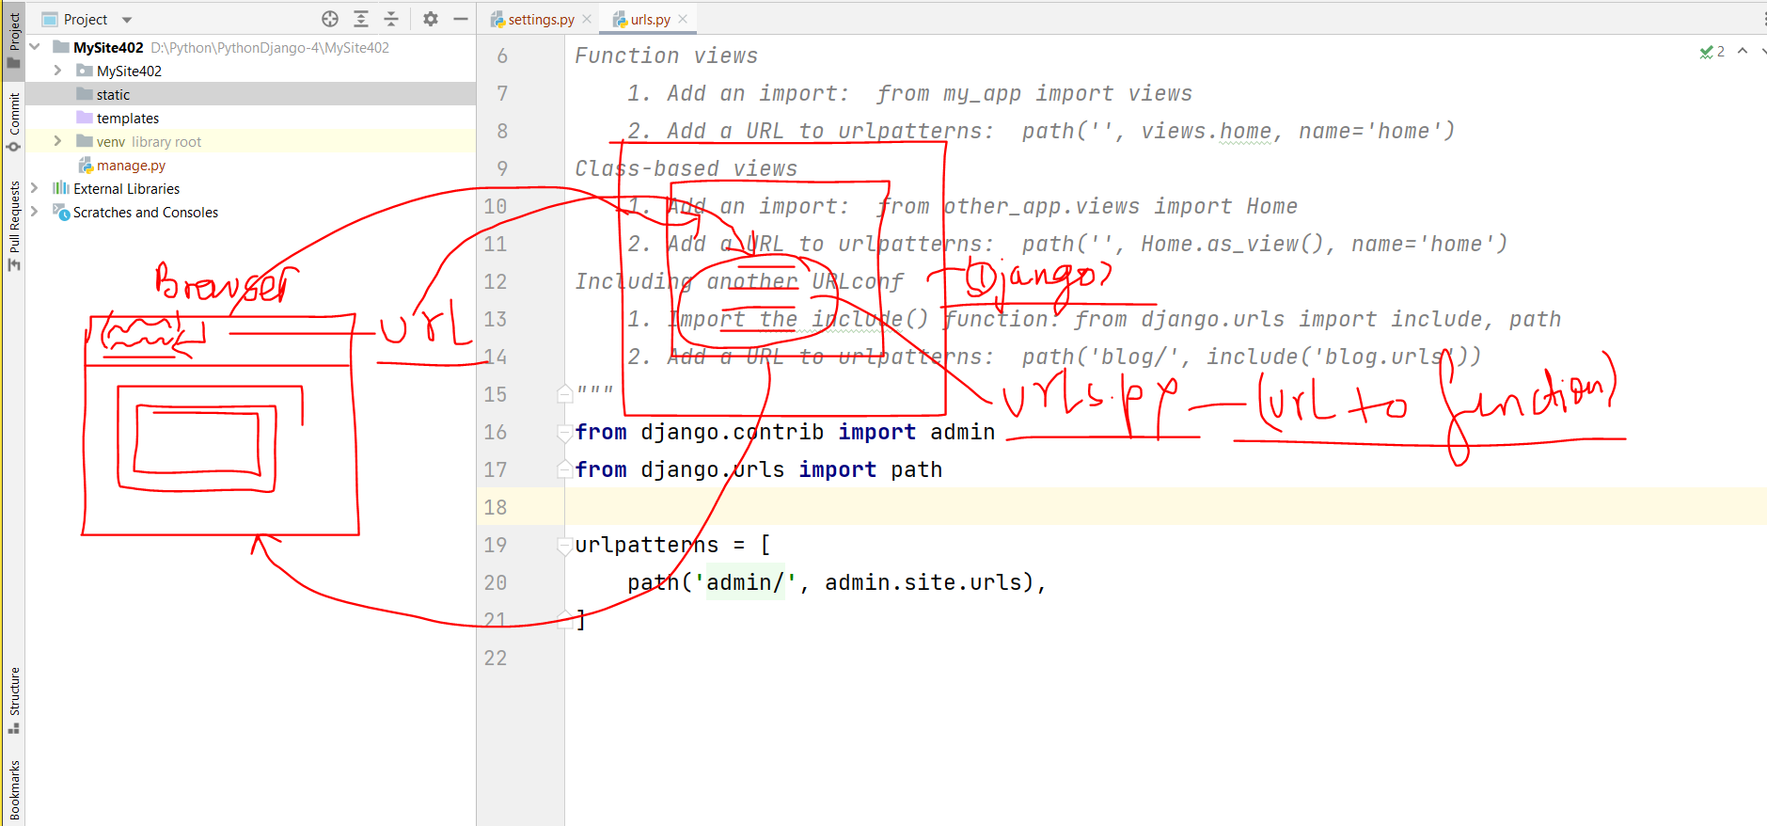

**settings.py**

**Testing/development**

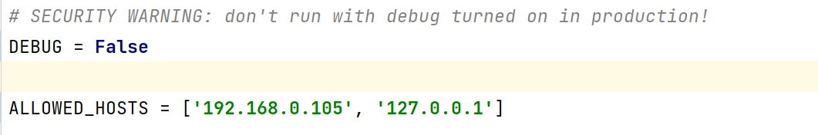

**Production/live site**

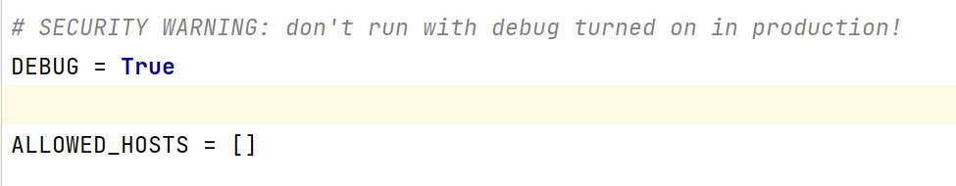

**Terminal > ipconfig/all**

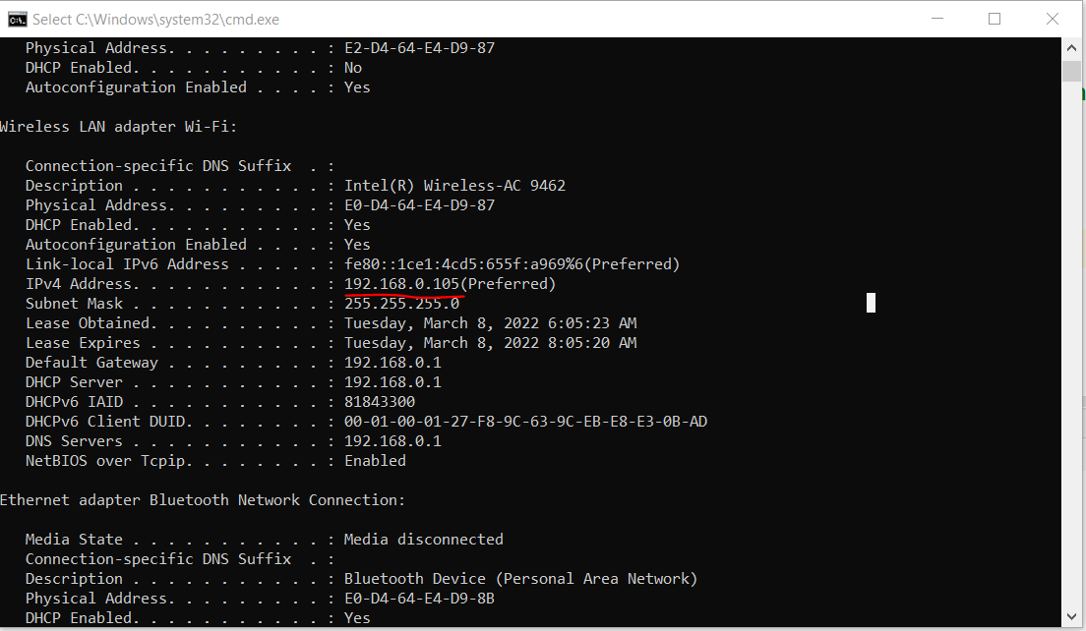

**5. Startring website (Up)**

**a.** Terminal **->** python manage.py **runserver**

**or**

b. Tools (Menu) -> **Run manage.py Task (Terminal of manage.py)**

**runserver**

**6. Website stop (down)**

Ctrl + Z or Ctrl + C

**7. Browse the website**

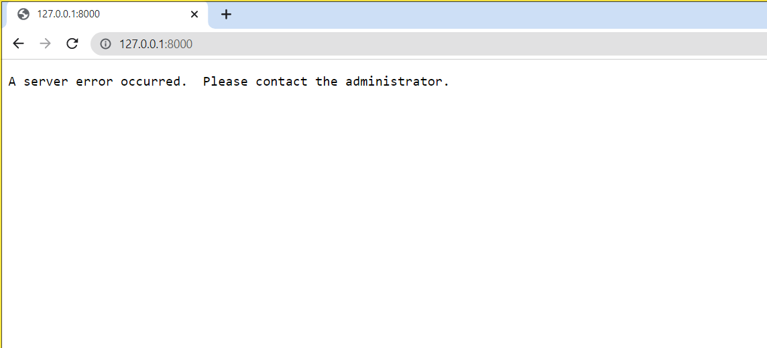

Port in Server Start

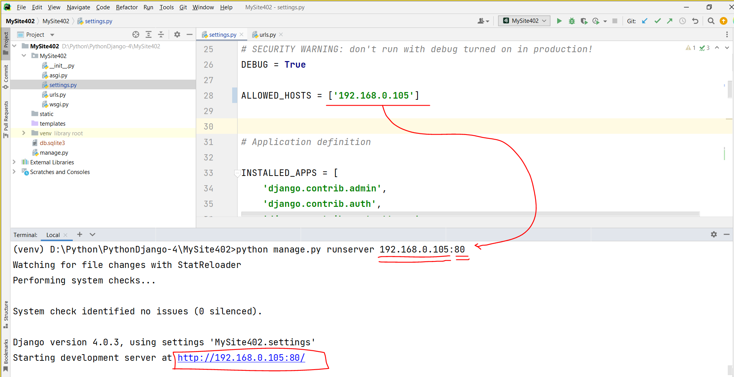

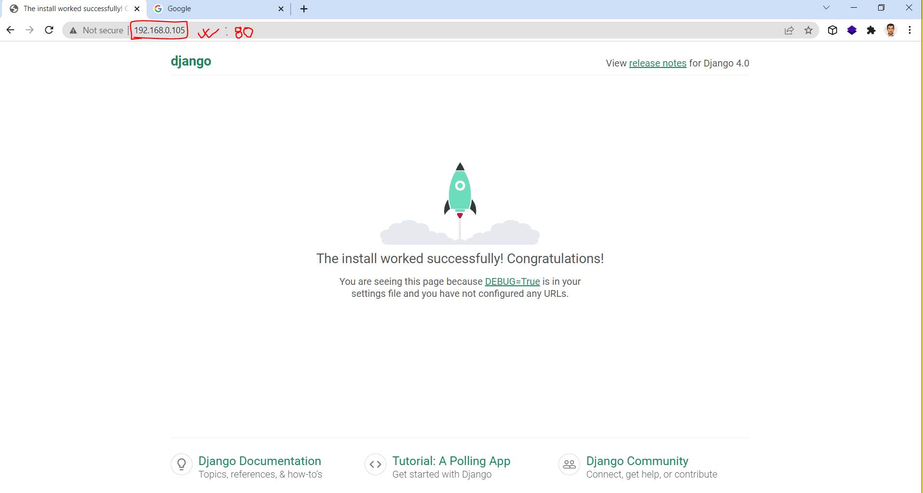

**Note:**

* **HTML, CSS. JavaScript**
* **Bootstrap**
* **Node**, and **Angular**/View/React JS